# Create tables in Hive and write queries to access the data in the table

**AIM:**

To create tables in Hive and write queries to access the data in the table.

# PROCEDURE:

1. Install the Apache Derby .
2. Download Apache Hive binaries and set the environment variables.

2a. Copy Derby libraries

we should go to the Derby libraries directory (db-derby-10.14.2.0\lib) and copy all *.jar files. Then, we should paste them within the Hive libraries directory.

2b. Configuring hive-site.xml and Hive’s Bin folder

Refer following link to download the file. Also download the guava file. Put hive-

site.xml file to hive’s conf location and replace hive’s current guava file with this one in lib location. Also download the bin folder from link and replace the existing hive’s bin folder.

https://drive.google.com/drive/folders/1r1OTDNcw8aF74V21k8GlD2IUGMJ_v11o?usp=drive_link

1. Starting Hadoop Services.

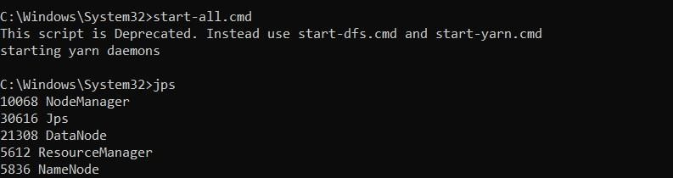

1. Start Derby Network Server: Run the following command in separate window to open Derby



1. Starting Apache Hive: Go to Apache Hive’s bin location with cd command and run the following command

hive --service schematool -dbType derby -initSchema

1. Open Hive shell by typing: hive

## Creating tables and accessing its data:

1. Create database name joshin and use that database to create table. Create a table named students with columns for student name, department, and age.

## CREATE DATABASE kanna;

**USE kanna;**

## CREATE TABLE students (student_name STRING,department STRING,age INT);

1. Insert data into the students table.

## INSERT INTO TABLE students VALUES ('Kanna', 'Computer Science', 150);

1. View the structure of the students table using the DESCRIBE command:

## DESCRIBE students;

1. List all tables in the current database:

## SHOW TABLES;

1. View the contents of the students table using a SELECT query:

## SELECT * FROM students;

**OUTPUT:**

1. Creating Database:

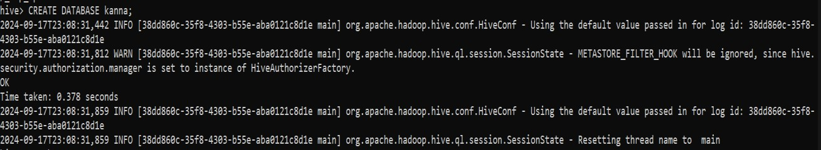

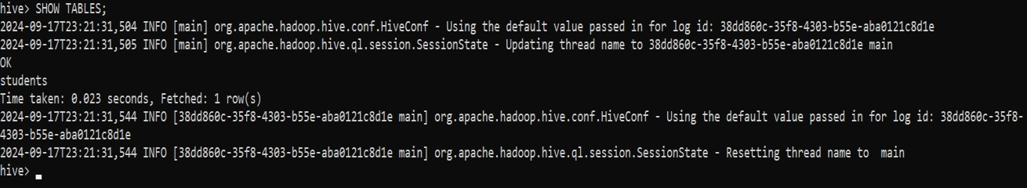

1. Use created Database to create table:

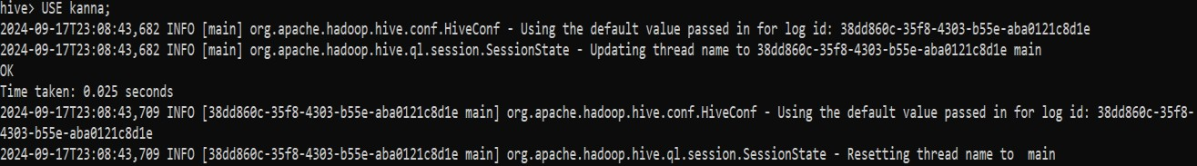

1. Creating table to store data:

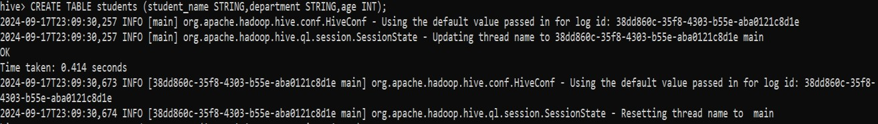

1. Inserting data into the table:

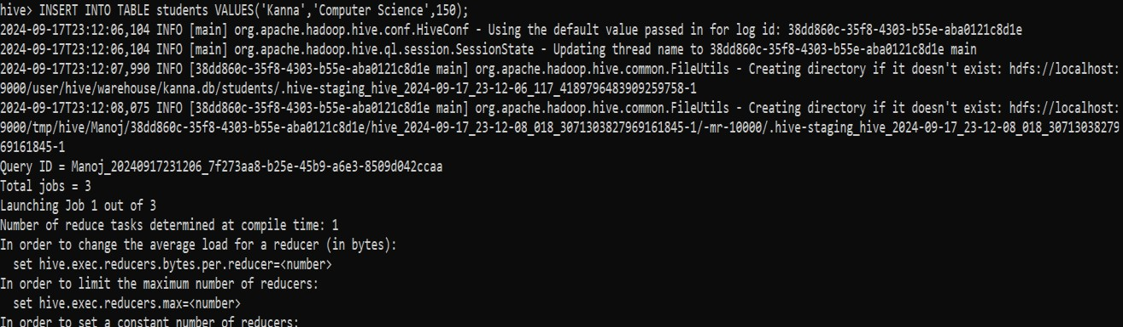

1. Viewing the created table:

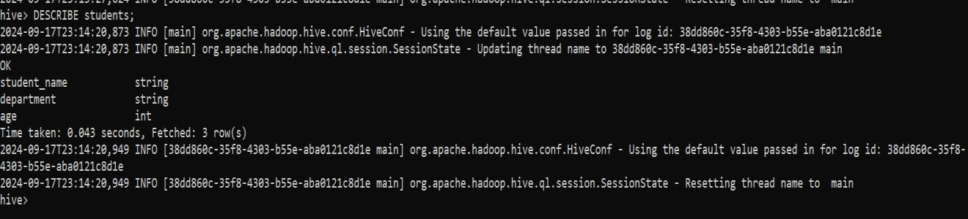

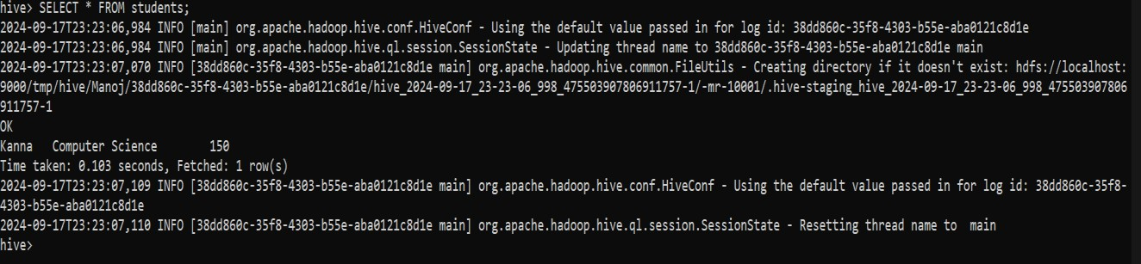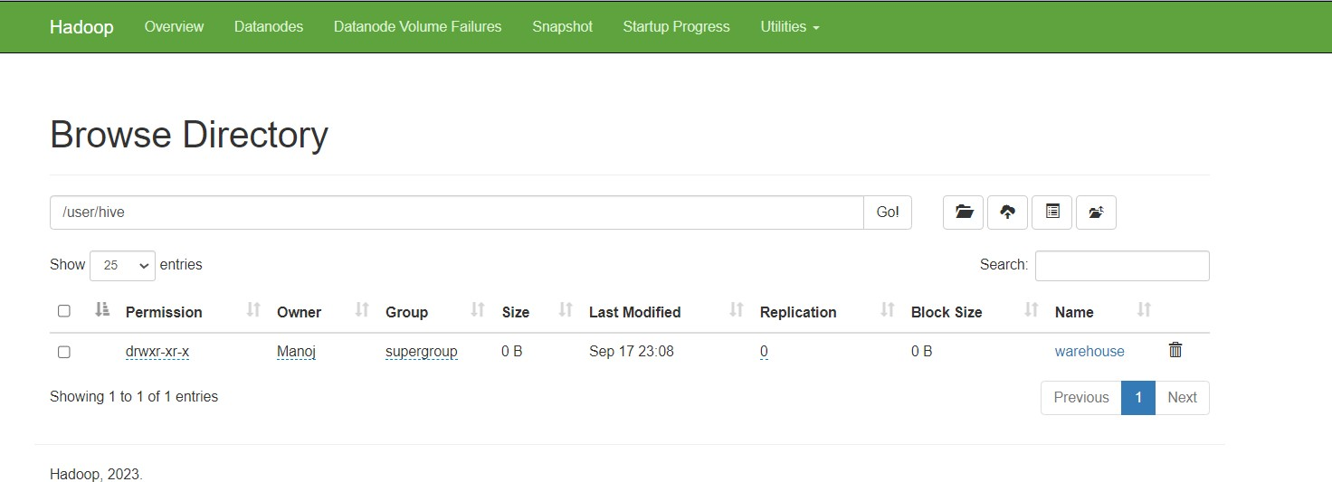

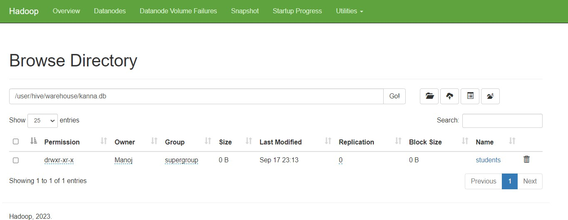

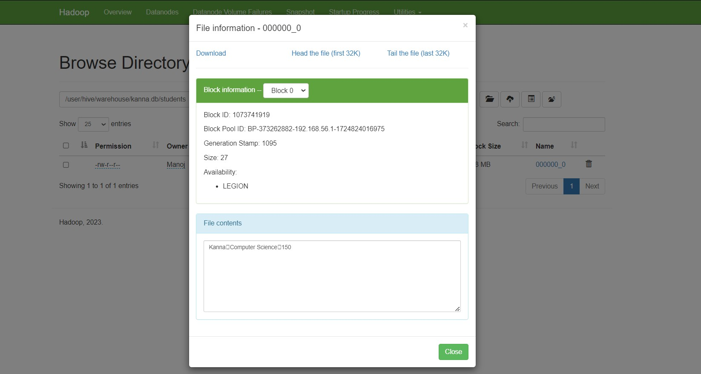

# RESULT:

Thus to create tables in Hive and write queries to access the data in the table is completed successfully.